**Problem Describtion:**

When viewing the interfaces, (use command: sudo vppctl show interface), I can’t see other ports such as GigabitEthernet2/2/0 and so on, but only *lo* port. The running environment of vpp is Vagrant. Figure 1 shows the result of showing interface, and the figure 2 is definition of physical ports for VM in the document “Vagrantfile”.

C:\Users\Administrator\Desktop\interface.png

figure 1

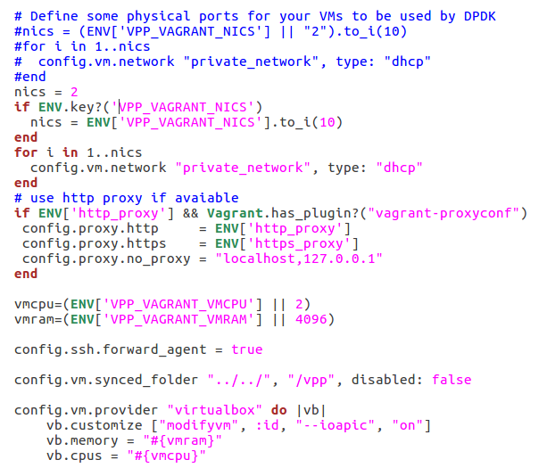

figure 2