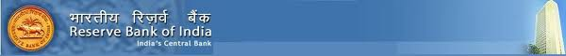From Office of the Reserve Bank Of India
6, Sansand Marg, (R.B.I) Building.PB NO 123.
New Delhi: E-Mail: rbi.depts@careceo.com
FROM THE FOREIGN EXCHANGE TRANSFER DEPARTMENT DESK RESERVE BANK OF INDIA
Our ref: Cbn/Ohg/Oxd1/2014
Telex: 09331Credit/RBI.
Payment file: RBI/Ben/009.
Attention: Beneficiary,
The Foreign Exchange Transfer Department Reserve bank of India has decided to bring to your attention, that you were listed as a beneficiary in the recent schedule for payment of outstanding debts incurred by the BRITISH GOVERNMENT pending since 2009 to 2014 According to your file record with your email address; your payment is categorized as:
Contract type: Lottery/inheritance/ unpaid contract funds/ Undelivered Lottery fund/

Payment amount: Rs. 3,50,00,000.00 Lac India National Rupees. Recently, on the 30th January 2014. The Reserve Bank of India (RBI) Governor, Dr. Raghuram Rajan and Ban Ki-moon Secretary-General of the United Nations met with the Senate Tax Committee on Finance RBI Mumbai/Delhi branch. Regarding unclaimed funds which have been due for a long run, at end of the meeting (RBI) Governor, Dr R. Rajan mandate all unclaimed funds to be release back to the beneficiary stating that it is an unfair practice to withhold funds for government basket for one reason or the other for tax accumulations. Therefore, we are writing this email to inform you that Rs. 3,50,00,000.00 Lac India National Rupees, will be release to you in your name.
Order has been give to the foreign transfer department in RBI to pay off the funds owners the total sum Rs. 3, 50, 00,000.00 Lac India National Rupees only and it will be Transfer to your personal account immediately.
GET BACK TO US WITH THE BELLOW DETAILS.
* FULL NAME:
* CONTACT ADDRESS:
* STATES:
* COUNTRY:
* AGE / SEX:
* MOBILE NUMBERS:
* OCCUPATIONS:
* NEXT OF KIN:
* EMAIL ID:
* BANK ACCOUNT DETAILS:

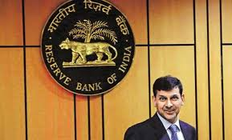
RESERVE BANK OF INDIA
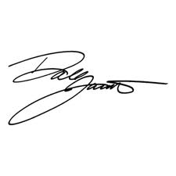
DR.RAGHURAM RAJAN
RBI GOVERNOR
rbi.depts@careceo.com

