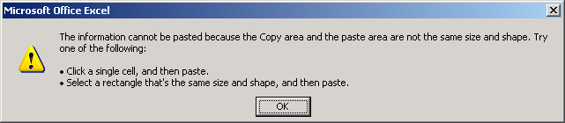

In my excel sheet in filtered mode all the cell contains formulae.while selecting all cells and copying and pasting as value the above said problem occurred.

Please assist how can I solve my problem.

The copying and pasting is a filtered mode.